|  |
| --- |
| Computing Studies  Information Processes & Technology |
| Information Systems for Broken Hill Surf Shop  Ryan Oo, Andrew Wong, 9IPT1  July, 2014 |

Table of Contents

Broken Hill Surf Shop 3

Project Planning 3

Business Requirement 4

Business Requirements 4

Website requirements 5

Sale Ticket 6

Systems Requirements 6

Information System Design 7

Broken Hill Surf Shop – Information Systems in Context Diagram 7

Environment 8

Users 8

Purpose 8

Information Processes 8

Participants 10

Data/Information 10

Information Technology 10

Boundary 12

Broken Hill Surf Shop – System Functions 12

Website Design 13

BHSS Webpage – Home Page 13

BHSS Webpage – Product Page 15

BHSS Webpage – Product Payment Page 16

Ticketing 17

Database Design (Flat file) 17

Product File & Design 17

Customer File & Design 18

Supplier File & Design 20

Employees and Privileges File & Design 20

Forms, Reports and Queries 23

Products 23

Customers 25

Suppliers 25

Employees and Privileges 26

Other Design Items 30

Broken Hill Surf Shop – Advertisement 30

Broken Hill Surf Shop – Customer Invoice 30

Bibliography 31

# Broken Hill Surf Shop

Broken Hill Surf Shop is owned and managed by Ryan Oo and Andrew Wong.  
Our shop is located at 10 Mica Street, Broken Hill, 2880, NSW. We have just bought the shop and have fully refurbished it to be our head office which can sit up to 10 employees and also have a small warehouse at the back.

We plan for most of our business to be from our online store called ‘Broken Hill Surf Shop’ and expect orders from the east and west coast cities of Australia, and some international business. Our vision for this business is “highest quality surf equipment at the best price!”. This means that our customers will have surf equipment that they can use happily for many years whilst being affordable.

 Our website, ticketing and customer invoices all have this logo on them. The logo is shaped as a surfboard, as the business is a surf shop. The image inside the logo is one of the beach, which is where most of our customers go once they have bought our high quality products.

# Project Planning

To make sure that we cover all the key parts of analyzing, designing and building our Information, we met and discussed the activities that we needed to do and who would be responsible for developing it and reviewing it.

|  |  |  |
| --- | --- | --- |
| Activities | Ryan Oo | Andrew Wong |
| Logo Development | Review, suggest improvements | To develop logo |
| Project Plan | We meet after most IPT lessons or after school classes to discuss what work needs to be done and who would ‘develop’ that and who would ‘review’. We meet often so that we can check our progress and also to make changes to our work and discuss if we can improve something. We exchange ideas and work using Skype and GitHub (Project management) and emails. | |
| Business Requirements | To develop requirement | To review and suggest changes |
| Systems Requirements | To develop requirement | To review and suggest changes |
| Website Design | To design website | To design website |
| HTML Coding | To do HTML coding (Payment) | To do HTML coding (Home,Products) |
| HTML Code Explanation | To review | To explain HTML code |
| BHSS Business Functions | To develop functions | To review and make suggestions |
| Database (Flat file) | To develop BHSS business data | To review and suggest changes |
| Advertisement | To review and suggest changes | To do advertisement |
| Information System Context Diagram | To develop Information System Context diagram | To review and suggest changes |
| Assignment Report | Jointly develop sections and review other sections | Jointly develop sections and review other sections |

This is our project schedule that we discussed for our key tasks. We exchange ideas and designs using GitHub which is a project collaboration and management tool.

|  |  |  |  |  |  |  |  |
| --- | --- | --- | --- | --- | --- | --- | --- |
| Activities | 13 June | 20 June | 27 June | 4 July | 11 July | 18 July | 25 July |
| Logo Development |  |  |  |  |  |  |  |
| Project Plan |  |  |  |  |  |  |  |
| Business Requirements |  |  |  |  |  |  |  |
| Systems Requirements |  |  |  |  |  |  |  |
| Website Design |  |  |  |  |  |  |  |
| HTML Coding |  |  |  |  |  |  |  |
| HTML Code Explanation |  |  |  |  |  |  |  |
| BHSS Business Functions |  |  |  |  |  |  |  |
| Database (flat file), Reports and Forms |  |  |  |  |  |  |  |
| Advertisement |  |  |  |  |  |  |  |
| Information System Context Diagram |  |  |  |  |  |  |  |
| Assignment Report |  |  |  |  |  |  |  |

# Business Requirement

## Business Requirements

The requirements of all aspects of our online and single shop business at Broken Hill.

* Shop hours. Our shop at 10 Mica Street, Broken Hill will be open:
  + From 8am-6pm Monday to Friday
  + On Thursday, we will close at 8pm
  + On Saturdays and Sundays we are closed.
* Online website
  + Our website will be available 365 days
  + And will be operating 7 x 24 hours everyday
  + From time to time, we will need to update our website and will provide notification on our website when it will be unavailable and when it will be available
  + Our website is very secure and uses 128-bit secure encryption of every transaction and payment
* Managing products
  + Must be able at least 50 surfing products
  + Be able to allow product quantity to be added/subtracted as appropriate and for the available balance to be displayed to customer and internal staff
  + Be able to set and show any discounts applicable to the product
  + Be able to set and show the suppliers of that product
  + Able to capture:
    - Stock code
    - Barcode
    - Item name
    - Cost price
    - Sale price
    - Supplier ID
    - Discount flag
    - Discount percentage
  + Able to set a minimum stock number to alert when there is low stock, so the warehouse manager knows when to order new products
* Managing customers
  + Be able to capture and update customer details
  + These details at a minimum are:
    - Customer ID
    - Last name
    - First name
    - Address including postcode, state and country
    - Contact details – phone, email
* Managing suppliers
  + Be able to capture and update supplier details
  + These details at a minimum are:
    - Supplier ID
    - Supplier name
    - Address including postcode, state and country
    - Contact details – phone, email
* Managing staff
  + Be able to capture and update employee details
  + These details at a minimum are:
    - Employee ID
    - Last name
    - First name
    - Roles allowed are:
      * Administrator (x2)
      * Sales consultant (x2)
      * Help Desk
      * Warehouse manager
      * Accountant
      * IT Support
    - Address including postcode, state and country
    - Contact details – phone, email
    - When employed
    - Salary
* Payment methods
  + Instore
    - Cash
    - Master card
    - Visa card
    - Cheque
  + Online.
    - Master card
    - Visa card
    - American Express
    - PayPal (function to be provided later)

## Website requirements

As we expect most of our business to be from our online store, it is important that our website can:

* Be easy for a customer to use
* 3 clicks to select, buy and pay
* Be available public holidays and weekends too
* Have a main online store webpage
* Able to navigate to Product and Payment pages
* Capture payment details
* Able to record customer details for delivering orders.
* Able to accept credit card payments from customers.
* Allow customers to select pickup or delivery options.
* Clearly show delivery charges ($5 for Australia wide, within 2 days) and ($20 for overseas, within 2 weeks) delivery
* When a product is purchased, the next page must:
  + Provide a description of the product
  + Provide the sale price (with any discount applied)
  + Display the stock code
  + Display barcode
  + Display available quantity
  + A “BUY” button
* On selecting the “BUY” button, the next page must :
  + Show total item price
  + Show full price of purchase(s) including delivery charges
  + Record credit card name on the card (for AMEX, Mastercard, VISA only)
  + Record credit card number
  + Record credit card expiry date
  + Record CVC number
* Allow customers to set themselves up as loyalty customers with a logon id and password (future)
* Allow staff to change products and prices
* Able to add new products and suppliers
* Able to process payments to suppliers
* Able to process employee and salaries
* A future requirement is to be able to record points so that for every 1,000 points, the next customer purchase will have 20% of the sale price (future)
* Must have a link to the full product list database

## Sale Ticket

Create a sale ticket for each product with:

* Stock code
* Barcode
* Item name
* Sale Price
* Discount (if any)

## Systems Requirements

The Broken Hill Surf Shop Information Technology system must:

* Be able to support at least 10 employees, Monday to Friday and one help desk user on weekends
* Support for at least 10 user computers connected through a LAN
* Be able to support up to 20 customers shopping online daily
* Provide these office software:
  + Microsoft Word processing for invoicing and other communications with customer, employees and suppliers
  + Microsoft Access for database management
  + Email for office, supplier and customer messages
  + Microsoft PowerPoint for marketing and advertisement work
* Be able to support the usage of a Microsoft Windows operating system
* 1 high speed printer (50 ppm) for sales and online orders
* 1 high speed printer (50 ppm) and scanner for reporting and business use
* Have a hard disk drive for daily backups of all customer orders, supplier invoices, inventory, sales data, financial data and reports. This hard disk will be kept at a separate location for safety.
* Have 2 x high capacity USBs for hourly and daily backups of all customer orders, supplier invoices and financial data for the last 2 months.

# Information System Design

There are many parts of designs that we will need to perform for our Broken Hill Surf Shop online and shop store. The following chapters will contain designs for:

* Describing the Information Systems Context diagram
* Overall systems functions design
* Website Designs
* Sales Ticketing
* Databases
* Forms, Reports and Queries

## Broken Hill Surf Shop – Information Systems in Context Diagram

**Purpose**

**Information Processes**

✓

Collecting

✓

Organising

✓

Analysing

✓

Storing and Retrieving

✓

Processing

✓

Transmitting and receiving

✓

Displaying

**Environment**

**Participants**

**Data/Information**

**Users**

Information Systems Context Diagram

**Information Technology**

### Environment

The environment of the Broken Hill Surf Shop computer system includes:

* The users of our systems such as customers and suppliers
* The participants in our system such as managers, warehouse staff and sales consultants
* Need to keep and use data and information such as products/inventory, customer details, supplier details, payment details and employee details
* Information Technology such as the LAN network, several servers and databases, backup and recovery devices and our BHSS online application
* The electrical power needed to power the system
* The communications such as the telephone the salesperson uses and email so the business can take orders
* The help desk assists customer who are having trouble using the website. The help desk is part of the environment because it is influenced by the information system, as the way the information system works affects how they can help online customers.

### Users

The users of this computer system include:

* The Supplier – As the supplier needs to know what to supply. The supplier also makes use of the information output from the Information System such as order forms or order file for more products.
* Customer – As they make use of the information output from the system, such as a copy of their order (invoice) and also select products and enter their personal and payment details
* The accounting staff – As they view and make use of the information output from the system, and they use it to manage funds, make budgets etc.

### Purpose

The purpose of the Broken Hill Surf Shop computer system is to capture, manage and report the day-to-day business transactions. The Broken Hill Surf Shop computer system also lessens the tasks that the office and warehouse Staff have to do, by automatically updating price and stock quantity information if the supplier changes their price and by making it easier to update how much stock is available in the inventory. Importantly, it will also generate customer invoices to inform our customers what products and the quantity they have ordered from us.

### Information Processes

* Collecting
  + The Broken Hill Surf Shop website collects customer details after they buy products.
  + The website also collects payment details eg. what credit card they would like to use
  + The salesperson collecting data after they have made a sale.
  + The accounting staff collects data concerning sales, profits etc
  + The warehouse manager collects information on the product inventory when the inventory is updated
  + Collecting employee information such as their last and first name, salary, date employed etc
* Organising
  + The organisation of the product inventory into categories eg. Product groups, sell price etc. This is because correctly sorted data improves the efficiency of other information processes
  + Organising customer data into the correct order eg. Last name, first name, contact details to deliver products they have bought, those who have paid and those still to pay for their orders
  + Organising employee details into departments and what computer functions they are allowed to perform, their years employed at BHSS
  + Organising the new products in the database into popular products that have sold a lot, by less popular products that have not sold well and products that are low stock and needing ordering
* Analysing
  + Analysing sales performance of products and also staff sales
  + Analysing which customers have paid for products ordered and which are yet to pay
  + Analysing which supplier’s orders have been received and when to pay them
  + Analysing which products are low in stock but are high demand, needing to be ordered quickly
  + Analysing customer trends (eg. Purchase time, the product itself, payment method, are the products bought discounted) to adjust the prices accordingly
  + Running queries on sales performance, product sales, product orders
  + Searching for product information
  + Analysing whether there are enough products in our inventory for today’s sales, tomorrow’s sales, this week’s sales
  + Analysing the company’s online versus in-store sales
  + The manager analyses employee performance
* Storing and Retrieving
  + Storing the updated product inventory on the managers computer and backup hard drives
  + Storing new online customer details
  + Storing new invoices and orders
  + Storing information of new items the shop is selling
  + Retrieving past transactions to see which products are selling well, or poorly
  + Retrieving past reports to compare against present reports, to see how the business is performing
* Processing
  + Processing customer order transactions
  + Processing supplier deliveries
  + Processing changes in stock levels as customers place orders and suppliers make deliveries
  + Processing trends in customers buying products, finding out which are the best selling products to adjust prices accordingly
  + Processing whether there is enough products available for a customer to buy
  + Updating accounting ledgers on profit and loss, accounts by debiting and crediting
  + Processing tax payments
  + Processing refunds for cancelled orders or returns
* Transmitting and Receiving
  + Transmitting orders to suppliers
  + Transmitting customer invoices, supplier orders and reports to printers
  + Transmitting payment data from users on the Broken Hill Surf Shop website to the database
  + Transmitting all reports, transactions, financial data, databases etc to backup hard drives
  + Transmitting that same information onto the managers’ computer hard drive
  + Receiving emails from suppliers who update the business on the shipment of their order/s and new products and discounts
  + Receiving telephone calls from customers who want to order products or customers who have problems with the online website
  + Transmitting credit card account details to PayPal or VISA/Mastercard, so PayPal or VISA or Mastercard can update the amount of money on the customer’s PayPal account or credit card
* Displaying
  + Displaying invoices on computer screens or paper by printing
  + Displaying financial reports etc on paper after printed
  + Displaying product details on computer screens or online website
  + Displaying receipts to customer after successful payments
  + Displaying stock on order from various suppliers
  + Displaying employee information such as functions they are allowed to use in the BHSS IT system
  + Printing receipts in store, once a customer has bought a product in the store

### Participants

The participants in this system are:

* The managers (Ryan and Andrew) – As they carry out and initiate the information processes within the system as they enter data into the system, to turn it into information eg. Making weekly reports
* Salesperson/s – Who put orders into the computer system as they initiate the processes in the information system
* Warehouse Staff – By starting processes within the information system, eg. update the stock inventory
* Accounting staff – As they generate profit and loss reports and tax payments
* Sales consultants – As they check stock or customer orders
* IT Support Staff – As they initiate the processes within the information system eg. when they add and remove employee login accounts

### Data/Information

The data/information in this computer system includes:

* The product information such as the price, stock code and barcode for the product
* The invoices printed out for the customer
* The customer’s details such as address, email address, contact number, credit card number etc
* Supplier’s details such as address, ABN number, phone number
* Employee information such as their last and first names, salary, date employed and functions they are allowed to perform on the BHSS IT system.
* Financial data, such as monthly yearly profits, debts, people who owe Broken Hill Surf Shop money etc.

### Information Technology

Our Broken Hill Surf Shop will have an online website store for customers to browse, select and pay for their online purchases. We will need Information Technology to support this online store and also for our one shop at Broken Hill, 10 Mica Street which also has a warehouse next to it.

So our technology design must support:

* At least 10 employees performing different roles
* Must support at least 20 online users daily, 365 days a year
* Access to this system must be secure and based on the office roles agreed and also for our online customers
* It must allow us to backup important data in case of a server or database crash



The Information Technology our company will need as described in the diagram above are:

* Staff computer
  + 10 Laptops capable of fast processing and executing a large number of instructions at any given time, this is because our business requires large amounts of processing to take place. Our staff computers must also have large secondary storage for databases to be kept.
  + Windows 8
  + Microsoft Office with Word, PowerPoint, Excel, Access
* Router & Modem to connect the employees to servers
* USB Backup – 2 x USB3.0 64GB external storage
* External Hard Disk backup – 2 x Seagate 2TB Hard Drive
* Online server
  + 2.2 GHz, 2 x Intel Xeon ES-4600 processor
  + Each processor with 8 CPU cores
  + Microsoft Windows Server 2012
  + 5TB internal disk storage
* Report server – Dell R620 PowerEdge
  + Windows Server 2012
  + 2.2 GHz
  + 2 x Intel Xeon ES-4600 processor
  + Each processor with 8 CPU cores
  + Microsoft Windows 2012
  + 20TB internal disk storage
  + Microsoft SQL Server 2012 Enterprise Edition
* Spare server – same specifications as Report server
* High-speed sales printer – HP LaserJet Enterprise M651
  + Print, copy
  + 45 ppm black ink, 1200 x 1200 dpi
  + 45 ppm colour ink, 1200 x 1200 dpi
* High-speed report printer and scanner – HP LaserJet Enterprise MFP M680
  + Print, copy, scan, email, fax
  + 45 ppm black ink, 1200 x 1200 dpi
  + 45 ppm colour ink, 1200 x 1200 dpi
  + Scanner 600 x 600 dpi
  + Flatbed scanner
* Ethernet LAN hardware compatible with a 100 gigabit network so it can handle the large amounts of information the Broken Hill Surf Shop terminals require quickly
* Mouse
* Keyboard
* Network cables
* Office Phone system – Panasonic TDA30
  + Up to 20 handsets
  + Able to integrate with PC/laptops
  + NBN ready
  + Call distribution when busy
  + Auto answer
  + Self service buttons

### Boundary

The boundaries of the Broken Hill Surf Shop include:

* Supplier information system
* Customers internet

## Broken Hill Surf Shop – System Functions



These are the main functions of the Broken Hill Surf Shop online system. The functions include how customers shop online, how the system manages stock, how the system performs reporting, how the system manages employees and how the system performs backups. The functions shows how data flows in the system, and what actions are being performed by the system.

## Website Design

The following chapters describe the designs for Broken Hill Surf Shop online store:

* Home page
* Product details page
* Product payment page

### BHSS Webpage – home page

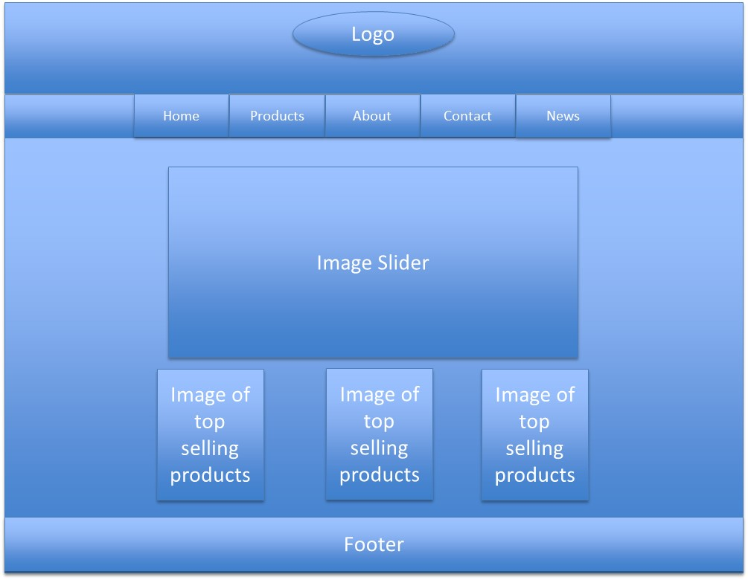The first diagram is the design of our home page that we discussed over a few days and exchanged ideas. The second diagram is a screenshot of our HTML home page.

The Broken Hill Surf Shop homepage has the logo and tabs on the header. The logo is featured on all Broken Hill Surf Shop online site pages. The tabs are home, product, about, contact and news, and customers can click on these tabs depending on where they would like to go within the website. There is a link to the database on the top-left hand corner of the page. Below the header is an image slider, which displays images of the products of Broken Hill Surf Shop along with the store on 10 Mica Street Broken Hill. Below the image slider is images of Broken Hill Surf Shops top selling products. Below that is the footer, which contains links to other areas within the website and it also contains contact details for Broken Hill Surf Shop. There is also a copyright statement in the footer.

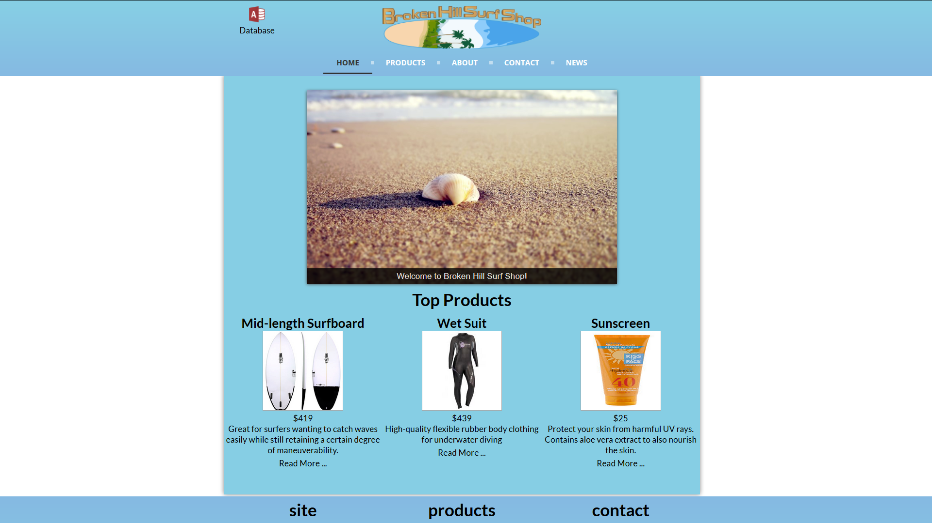

### BHSS Webpage – Product page

The first diagram is the early rough design of our product details page that we discussed over a few days and the second diagram is a screenshot our HTML product details page.

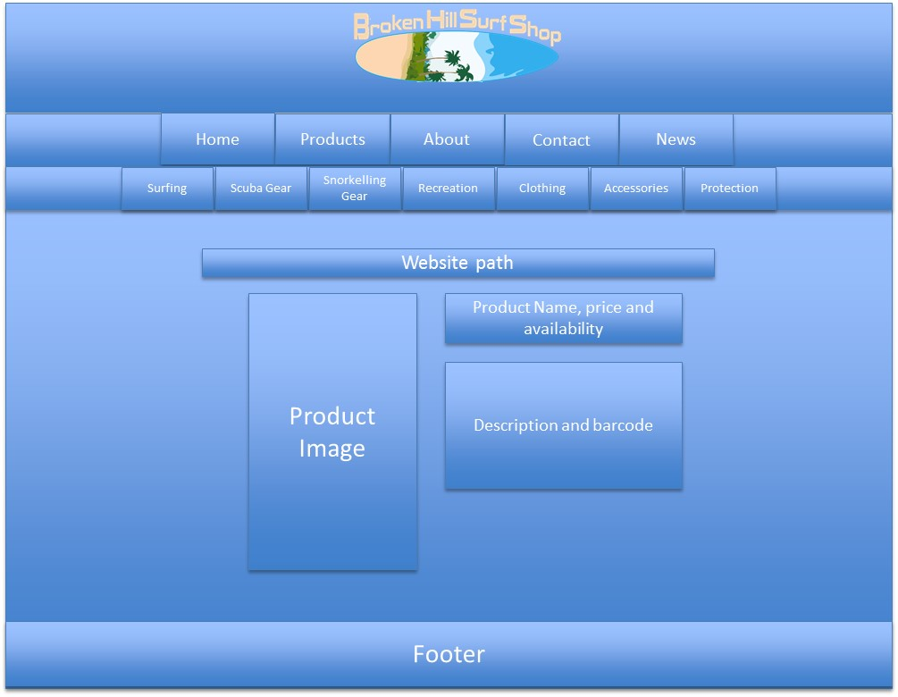

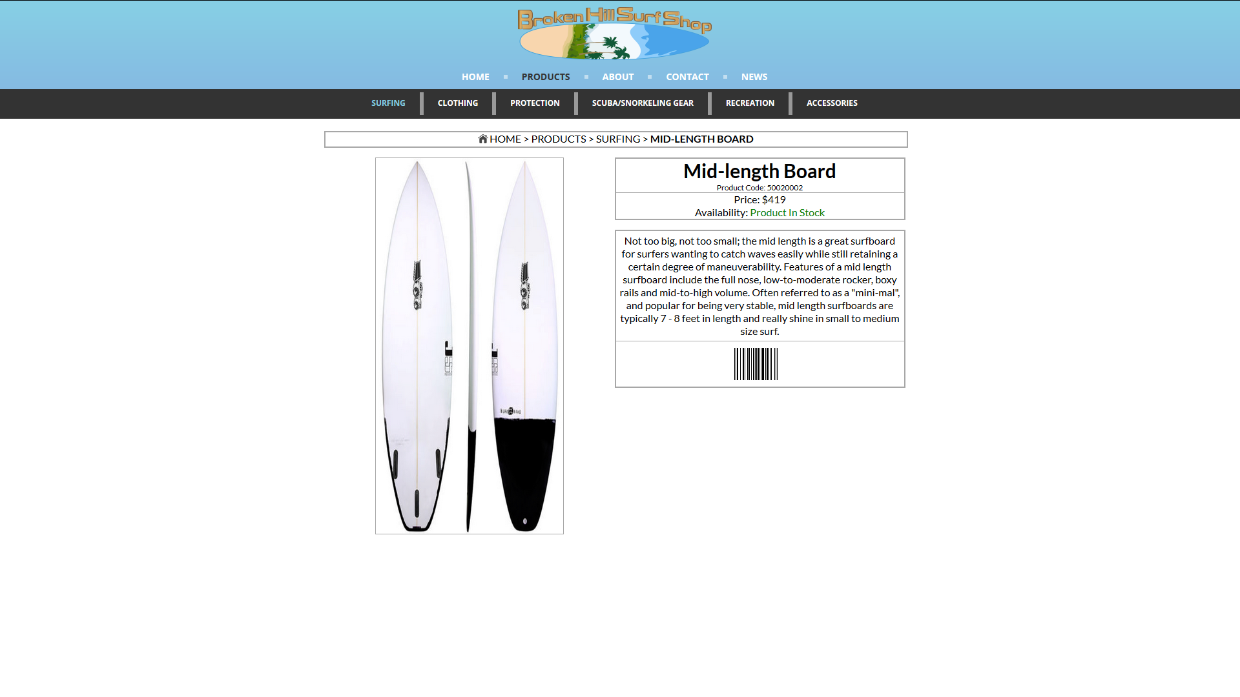The product page is the page entered after clicking the tab “PRODUCTS” in the home page. Below the header are tabs of various product groups. The product page includes images and descriptions of the product, with prices and availability also included. This is a very exciting page as it describes all our high quality products to our customers and also our sales staff.

### BHSS Webpage – Product Payment Page

The first diagram is a sketch of what our payment page will look like after a customer has selected one of more products to buy from our online store. He/she will be allowed to select how they want to pay for the purchase. We accept VISA, Mastercard, American Express credit cards and PayPal.

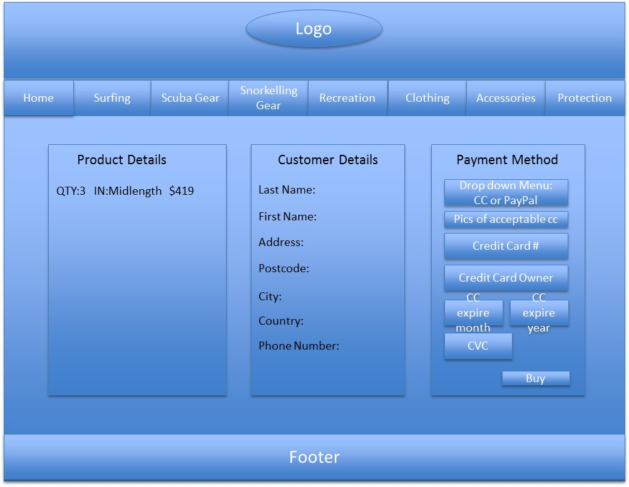

This following HTML product payment page is shown when the customer clicks on the buy button, on the product page. On the left side of the page is the product image, along with the quantity of the order and the price of the product. In the middle the customer enters their personal information. On the right is where the customer inputs their payment method

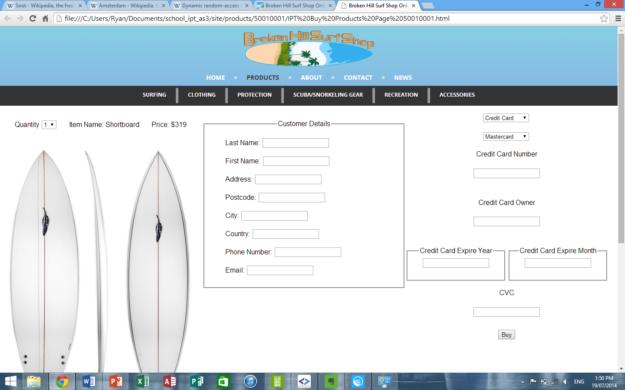

## Ticketing

The BHSS product tickets use EAN-8 barcode format. These are linked to the Product ID and has been generated for the products we sell. The example below of a product ticket has been created using Microsoft Word Mail merge with the selected Access Database table named Products. The relevant items were selected from the table and merged automatically to generate these tickets. We also inserted our company logo.

|  |  |
| --- | --- |
| Highest quality, best price!!  Item Name - Shortboards  Product Group - Surfing  Sale Price - $319  Discount - 0%  Stock Code - 50010001 | Highest quality, best price!!  Item Name - Mid-length  Product Group - Surfing  Sale Price - $419  Discount - 0%  Stock Code - 50020002 |
| Highest quality, best price!!  Item Name - Longboards  Product Group - Surfing  Sale Price - $450  Discount - 10%  Stock Code – 50030003 | Highest quality, best price!!  Item Name - Bodyboards  Product Group - Surfing  Sale Price - $169  Discount - 0%  Stock Code – 50040004 |

## Database Design (Flat file)

The following is a screen shot of our BHSS Product database in Microsoft Access.

### Product File & Design

Our online store and shop at Broken Hill have a full range of modern and high quality surfing gear ranging from surf boards to goggles. These are all at very affordable prices and from time to time we even have sales where certain items are discounted. Presently we have about 50 types of items for sale. These are described in our Access database, with a screen shot below as an example.

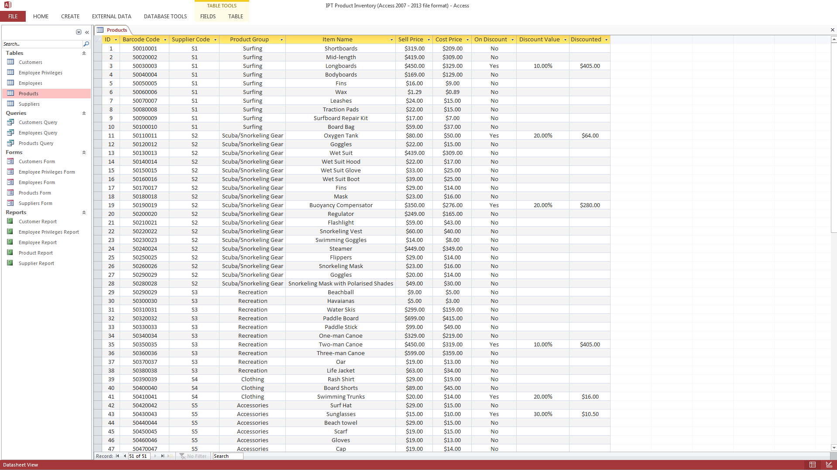

The Product database consists of these data fields/features.

* Allows any number of products to be recorded for sale.
* It also allows products to be grouped into product groups so that they can be easily displayed for customer to browse using a drop down list for more details.
* Types of surfing products on sale are captured in the Access database with:
  + Barcode – The barcode format chosen for this business is ‘EAN-8’. It has 8 numeric digits as it is designed to fit on small items such as cigarette packages. Numeric data is the only data value allowed on this barcode.
  + Supplier code – The code for each supplier that Broken Hill Surf Shop orders products from. Only letters and numbers are allowed. Supplier codes are two digits
  + Product group – The groups in which the items are classified. These groups are also the tabs shown in the BHSS HTML website. Alphabets only.
  + Item Name – This is a short description for each of the products on sale. Up to 22 characters are allowed.
  + Sell Price – This is the selling price of each item at a particular business day and may change from day to day. This price includes our profit margin markup and we check other surf shops on a regular basis to ensure our prices are realistic and affordable. Only numbers allowed.
  + Cost Price – This is the price that we pay our supplier for the product before we add our profit margin. Only numbers allowed.
  + On discount – This flag indicates whether items are on discount or not. Yes means they are on discount and no means they are not on discount. Only ‘Yes’ and ‘No’ are allowed.
  + Discount value – Broken Hill Surf Shop allows discounts, ranging from 10% to 30% off the original price.
  + Discounted price – The selling price, with the discounted value taken into account.

### Customer File & Design

As a business, BHSS will need to capture customer details so that we can send out invoices for products purchased, address to deliver purchases too and also customer details to follow up with payments or complaints. Customers can also be awarded loyalty points (in future) based on the number and value of items purchased.

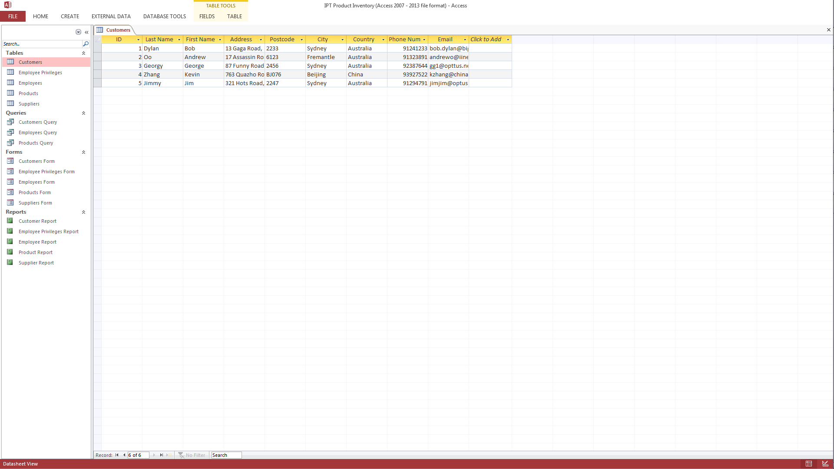

The Customer database consists of these data fields/features.

* Allows any number of customers and their details to be recorded.
* Customer details captured in the Access database are:
  + Last name – The family name of our customer. This must be in characters only, no numbers allowed.
  + First Name – The first or given name of our customer. This must be in characters only and no number allowed.
  + Address – This is the customer’s delivery address where he/she wants their products delivered too. It will contain a mix of characters and numbers.
  + Postcode – The postcode of the suburb. This can be a mix of characters and numbers to support not only Australian postcode but also International postcodes.
  + City – The city where our customer lives and wish their products to be delivered too. This must be in characters only.
  + Country – The country where our customer lives and wish their products to be delivered too. This must be in characters only.
  + Phone Number – Phone numbers of our customers and if they live overseas, they will need to include country code and city code in front of the phone number.
  + Email Address – The email address contact details for the customer. This can be a combination of characters, numbers and special characters eg. @.

Customer details must be protected from unauthorized access as Broken Hill Surf Shop must abide by the Data Privacy Act 1988. This is a legal requirement. In the Employee and Privileges section, we only allow certain roles to access and manage the customer database. Each time a customer orders or buys items from BHSS, their details will be captured via online web pages and stored in this Access database.

### Supplier File & Design

BHSS business will need to purchase the many surfing products we sell from suppliers in Australia and also overseas. We will buy high quality products only from reliable suppliers who have a good cost price.

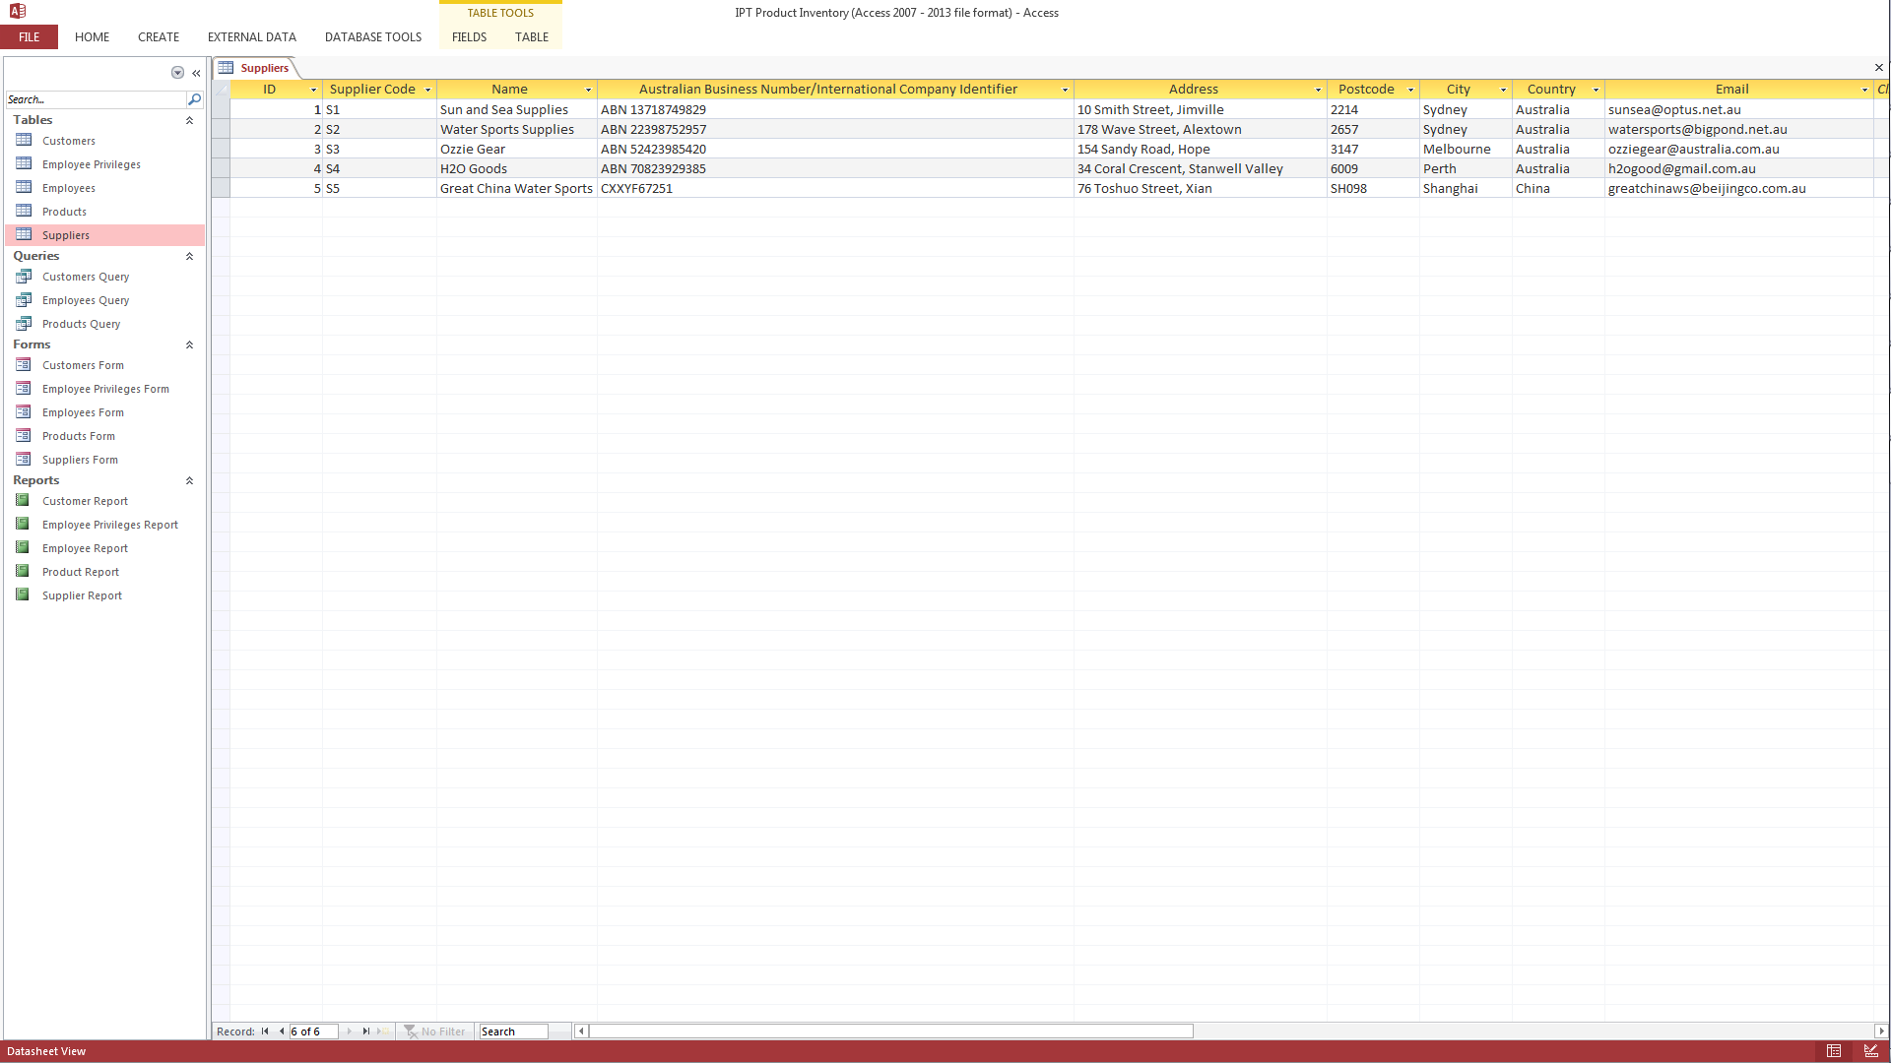

The Supplier database consists of these data fields/features.

* Allows any number of suppliers and their details to be recorded.
* Supplier details captured in the Access database are:
  + Supplier Code – This is a two digit code that uniquely identifies this supplier. The first character is an ‘S’ and the second is a number.
  + Supplier Name – This is the business name of our supplier. Up to 24 characters are allowed.
  + Australian Business Number/International Business Number – This field captures the ABN of companies doing business in Australia and also company codes for suppliers who are in other countries such as China, USA….etc. A combination of characters and numbers are allowed.
  + Address – This is the business address of our supplier and can be in Australia or overseas. A combination of characters and numbers are allowed.
  + Postcode – Postcode of supplier in Australia or overseas. A combination of characters and numbers are allowed.
  + City – The city where our supplier has their head office. Characters only.
  + Country – The country where our supplier has their head office. Characters only.
  + Email address – The email address of our suppliers. This can be characters, numbers and special characters.

### Employees and Privileges File & Design

The Broken Hill Surf Shop business consists of about 10 employess including the two joint owners. In order for our business to be secure and our customers details to be confidential, we will need a database of employees and their systems access priviliges recorded and managed as employees leave and new ones join up.

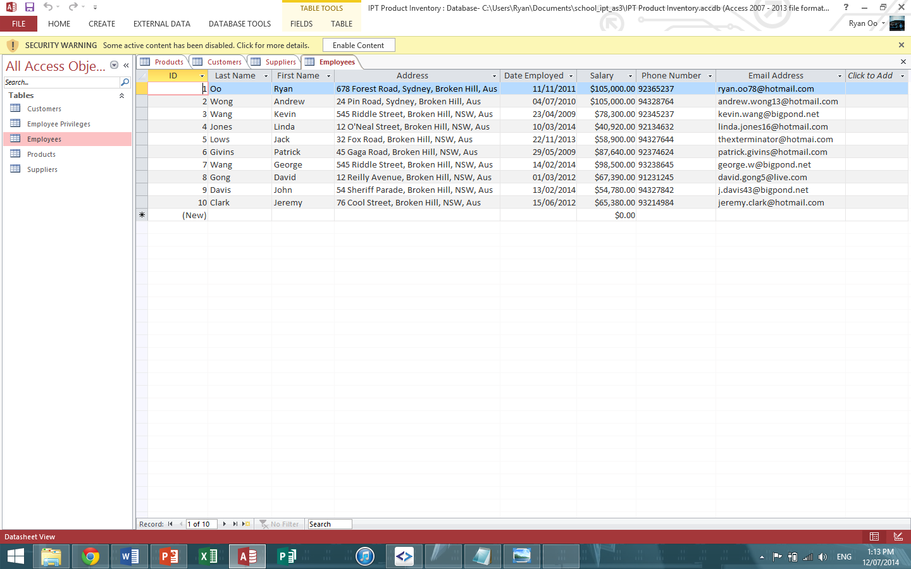

The Employee database consists of these data fields/features.

* Allows any number of employees and their details to be recorded.
* Employee details captured in the Access database are:
  + Last name – The family name of the employee. This must be in characters only, no numbers allowed.
  + First Name – The first or given name of the employee. This must be in characters only and no number allowed.
  + Address – This is the employee’s residential address where he/she lives. It will contain a mix of characters and numbers.
  + Postcode – The postcode of the suburb. This can be a mix of characters and numbers to support not only Australian postcode but also International postcodes.
  + Phone Number – Phone number of the employee. This is typically a number in Australia.
  + Email Address – The email address contact details for the employee. This can be a combination of characters, numbers and special characters (“@”)
  + Date Employed – The date the employee joined Broken Hill Surf Shop. This was automatically formatted in Microsoft Access and is in DD/MM/YYYY format.
  + Salary – This is the current salary of the employee. This is in Australian dollars and must be in numbers only.

The next Access database is the Employee Privileges database that determines which functions and systems they are allowed to use.

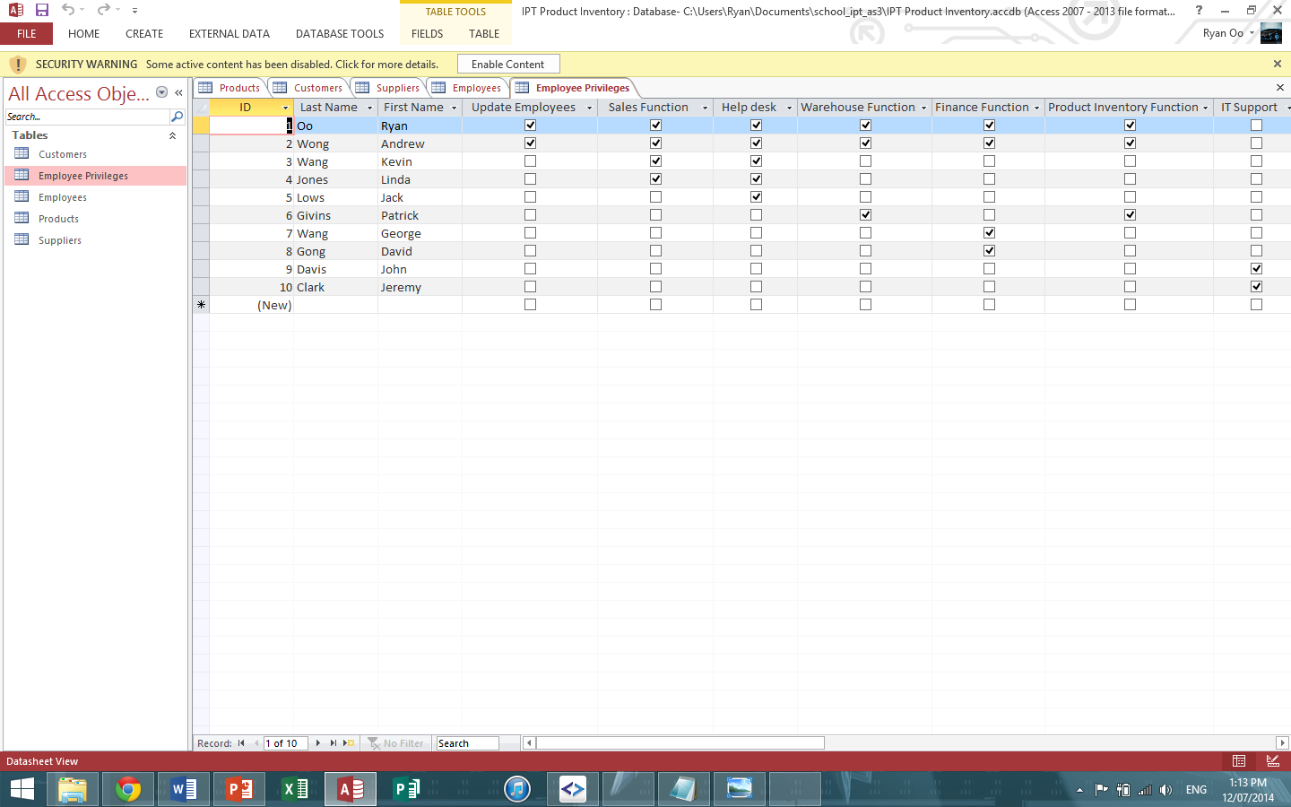

* + Last name – The family name of our customer. This must be in characters only, no numbers allowed.
  + First Name – The first or given name of our customer. This must be in characters only and no number allowed.
  + System access privileges. These are all set to ‘Y’ if the employee is allowed to use this function.
    - Update Employees – Allowed to add, update, delete employee records.
    - Sales Function – Allowed to perform the Sales Functions in BHSS IT system to sell products and manage customers.
    - Help Desk – Allowed to perform Help Desk functions to support customer enquiries or complaints or to assist customers with putting in an order.
    - Warehouse Function – Allowed to add, update, delete stock, change prices, rename items ….etc in the inventory either as customers buy products or as suppliers deliver new orders.
    - Finance Function – Allowed to perform debit and credits to various accounts and run financial reports.
    - Product Inventory Function – Allowed to add, delete and change stock quantity.
    - IT Support – Allowed to perform various operating systems commands, backup and software updates and changes.
    - Supplier Function – Allowed to add, change or delete supplier details.
    - Customer/Guest Function – Allowed to add, update, delete customer details and customer payment details.
    - Manager/Owner Function – Allowed to perform manager/owner functions such as changing employee salary, approving refunds to customers who are unhappy or have returned products, allowed to change product prices/discounts, allowed to generate financial and tax reports and make adjustments if numbers are incorrect.
    - Network/Logins – Allowed to add or remove employee logins to the BHSS Intranet or BHSS IT systems, to set/reset passwords.

# Forms, Reports and Queries

The following sections describe our database tables with forms, reports and example queries. The five reports have been created with “Report Wizard” using Microsoft Access. All data fields were included in each report.

## Products

Our product form.

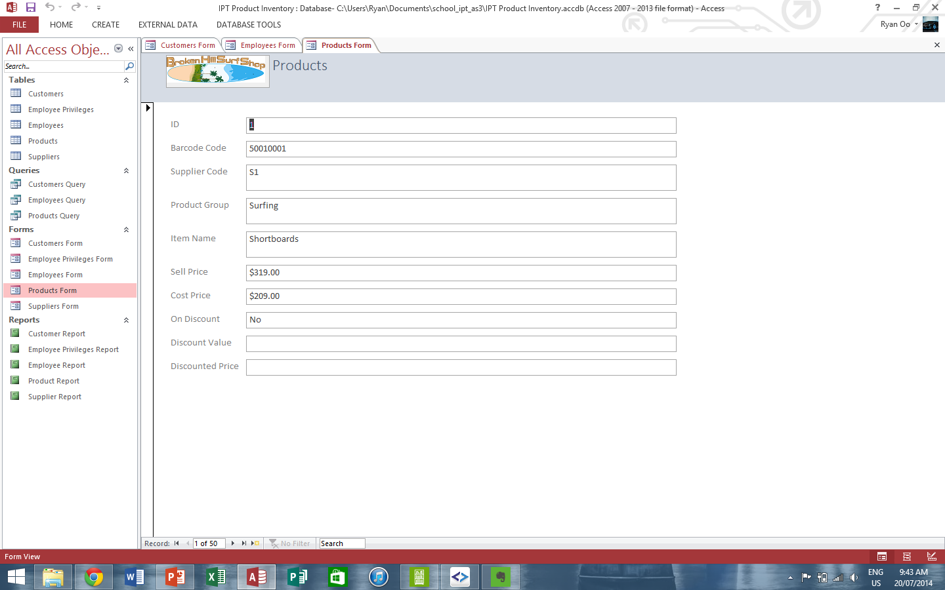

A report of our Products database.

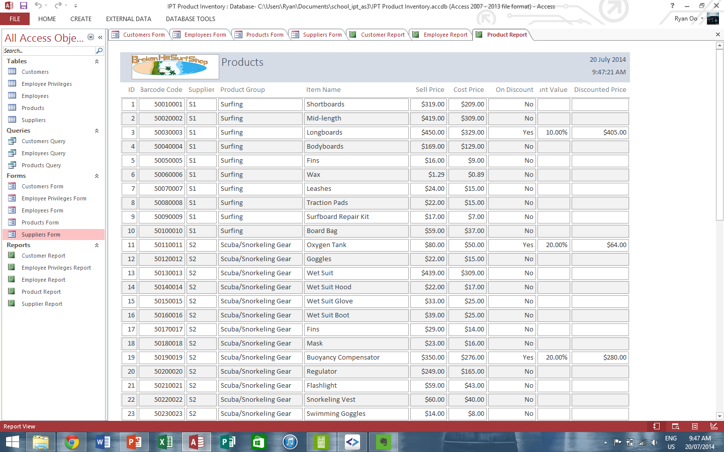

An example Query for all Products with a discount.

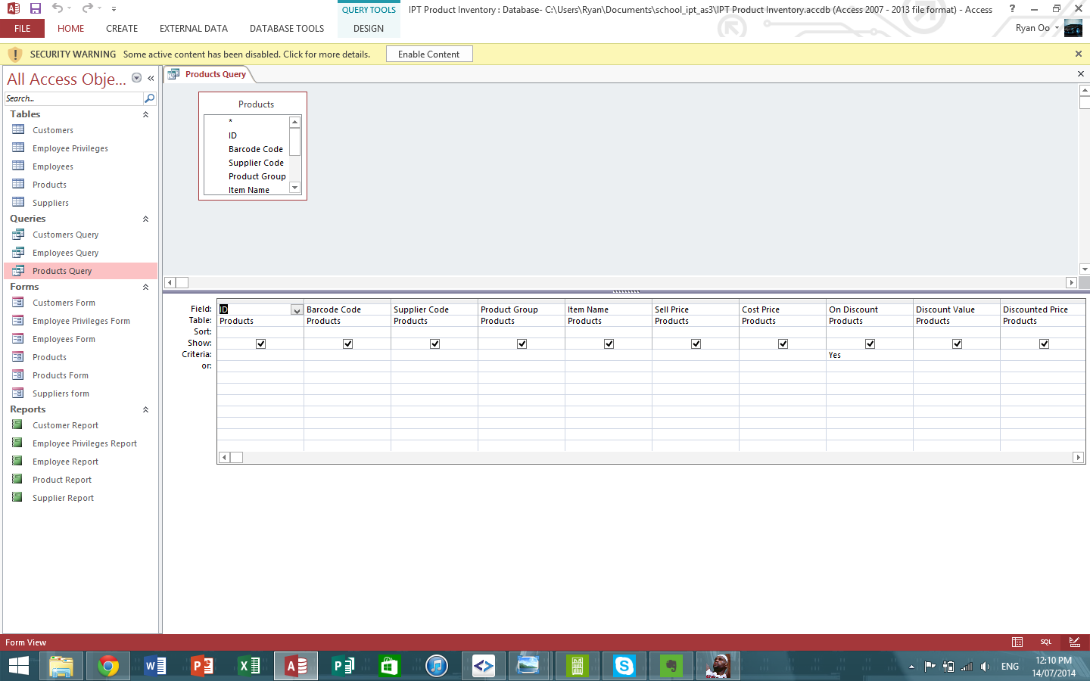

And the result of the Product Query from above is shown below. The SQL command for this query is:

*SELECT Products.ID, Products.[Barcode Code], Products.[Supplier Code], Products.[Product Group], Products.[Item Name], Products.[Sell Price], Products.[Cost Price], Products.[On Discount], Products.[Discount Value], Products.[Discounted Price]*

*FROM Products*

*WHERE (((Products.[On Discount])=Yes));*

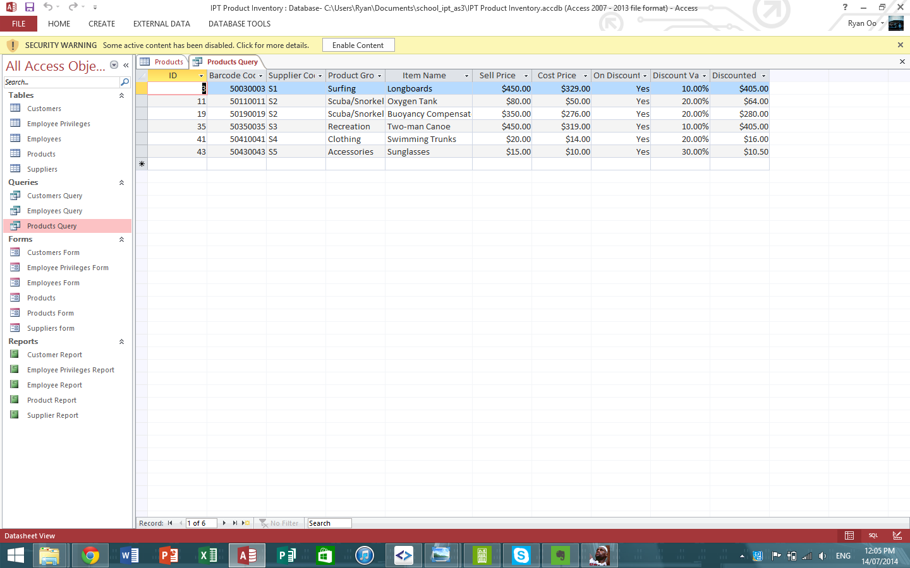

## Customers

Our Customer form.

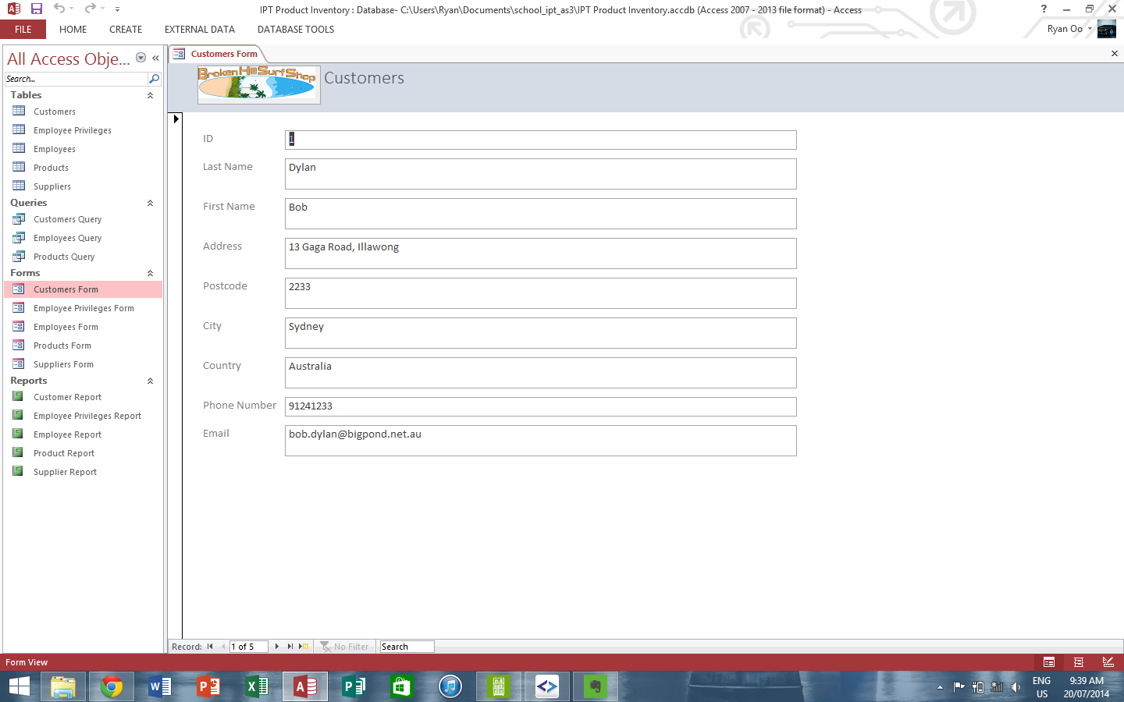

A report of our Customers database.

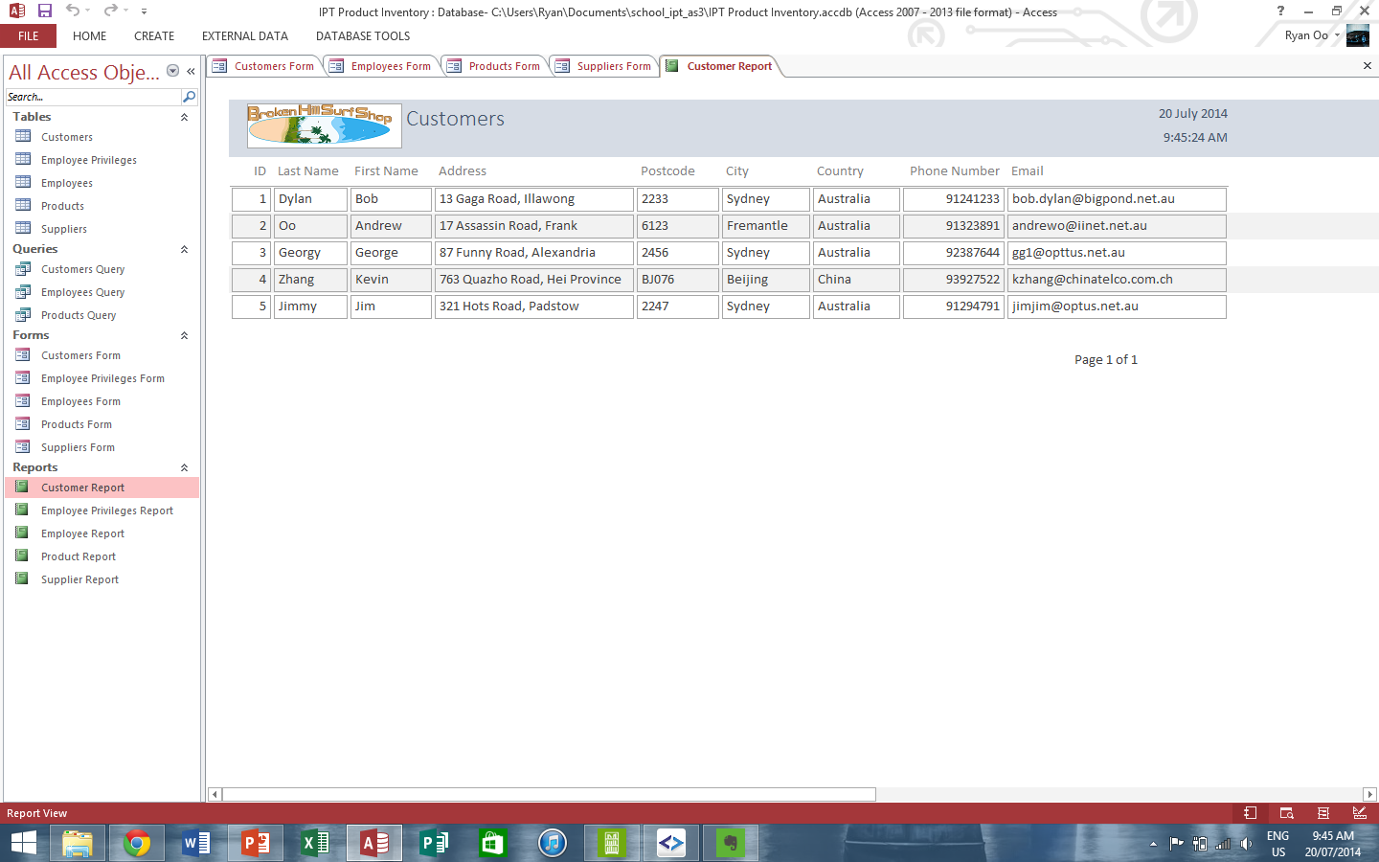

## Suppliers

Our Supplier form.

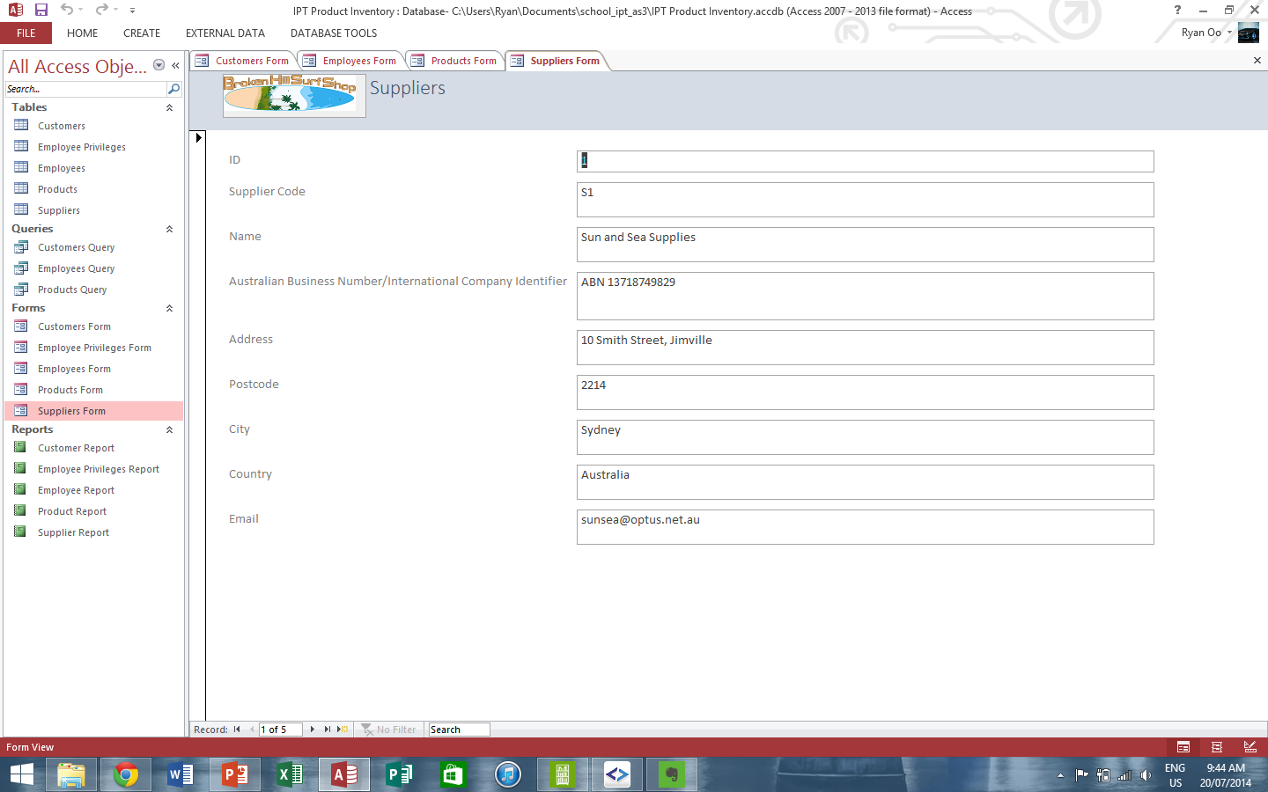

A report of our Suppliers database.

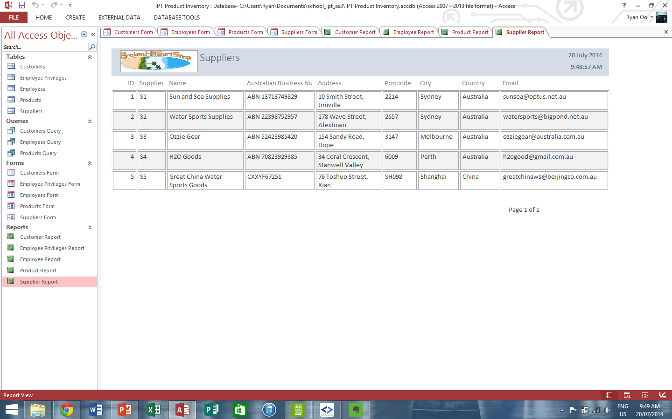

## Employees and Privileges

Our Employee and Employee Privileges forms.

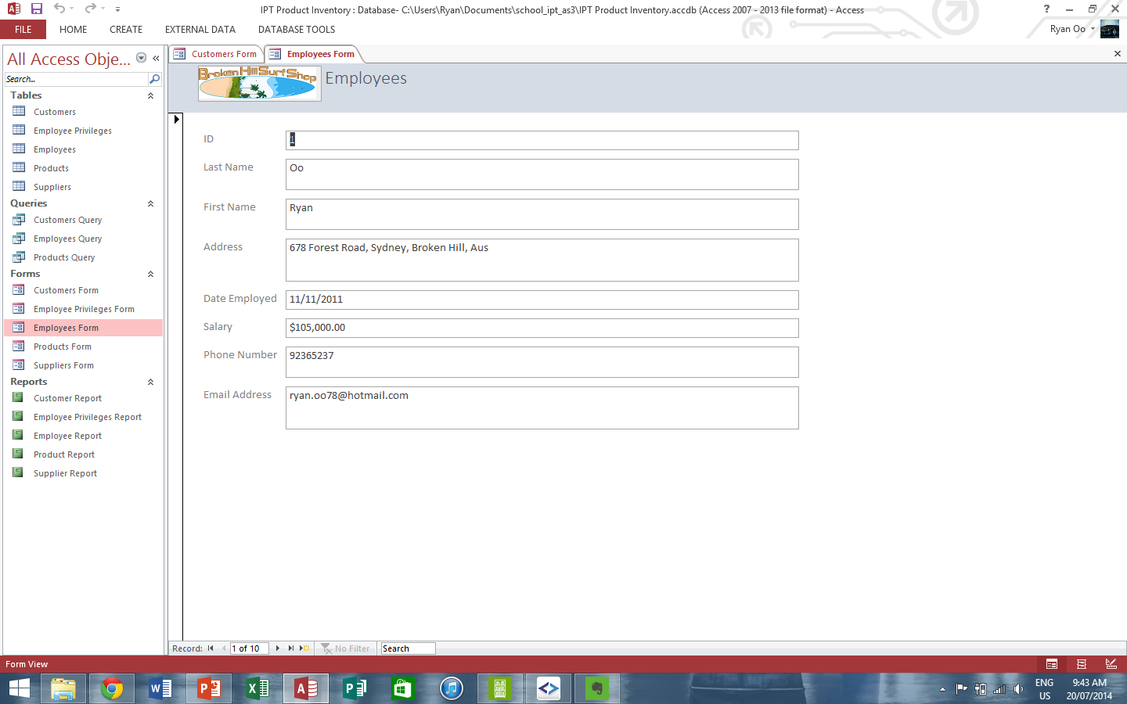

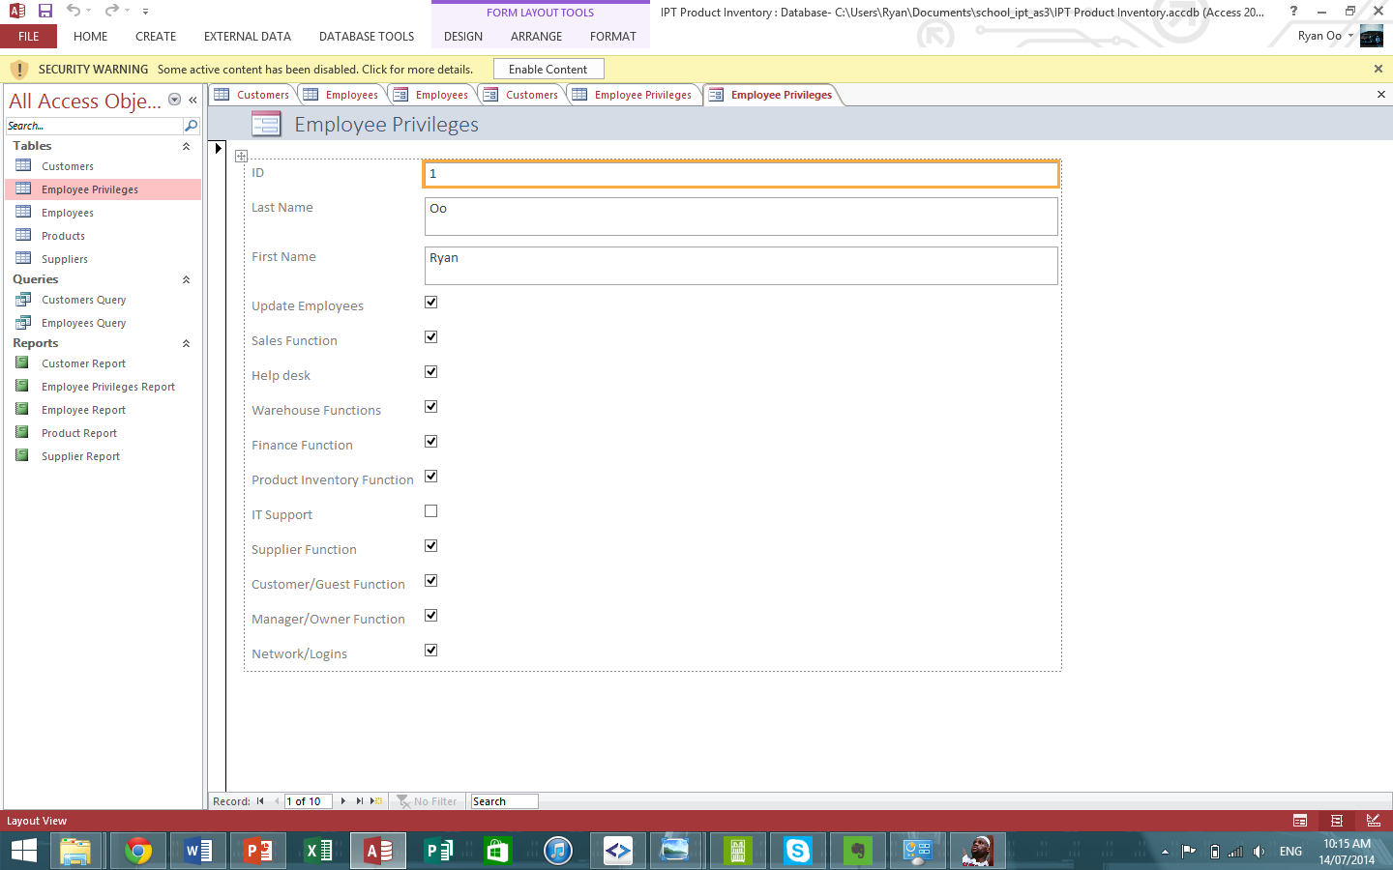

A report of our Employees and our Employee Privileges databases.

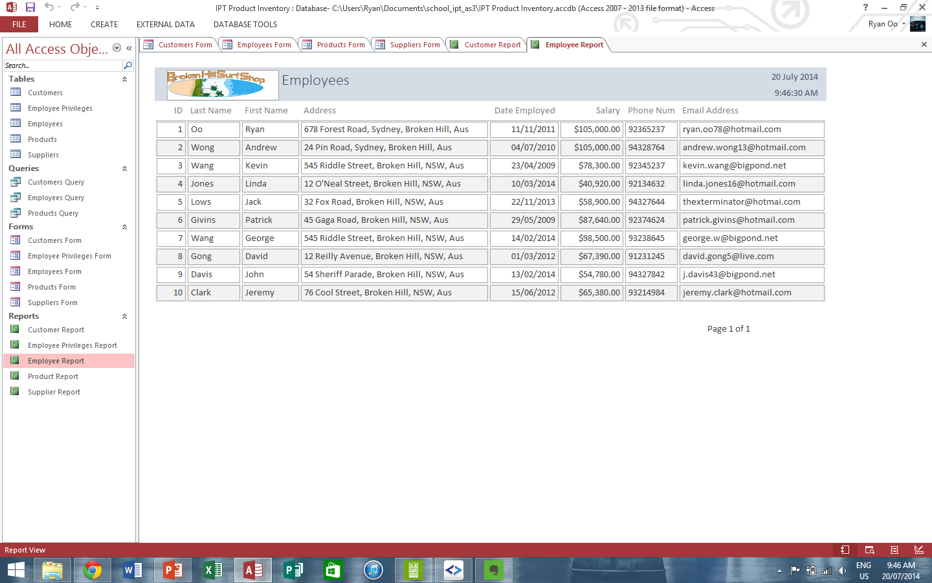

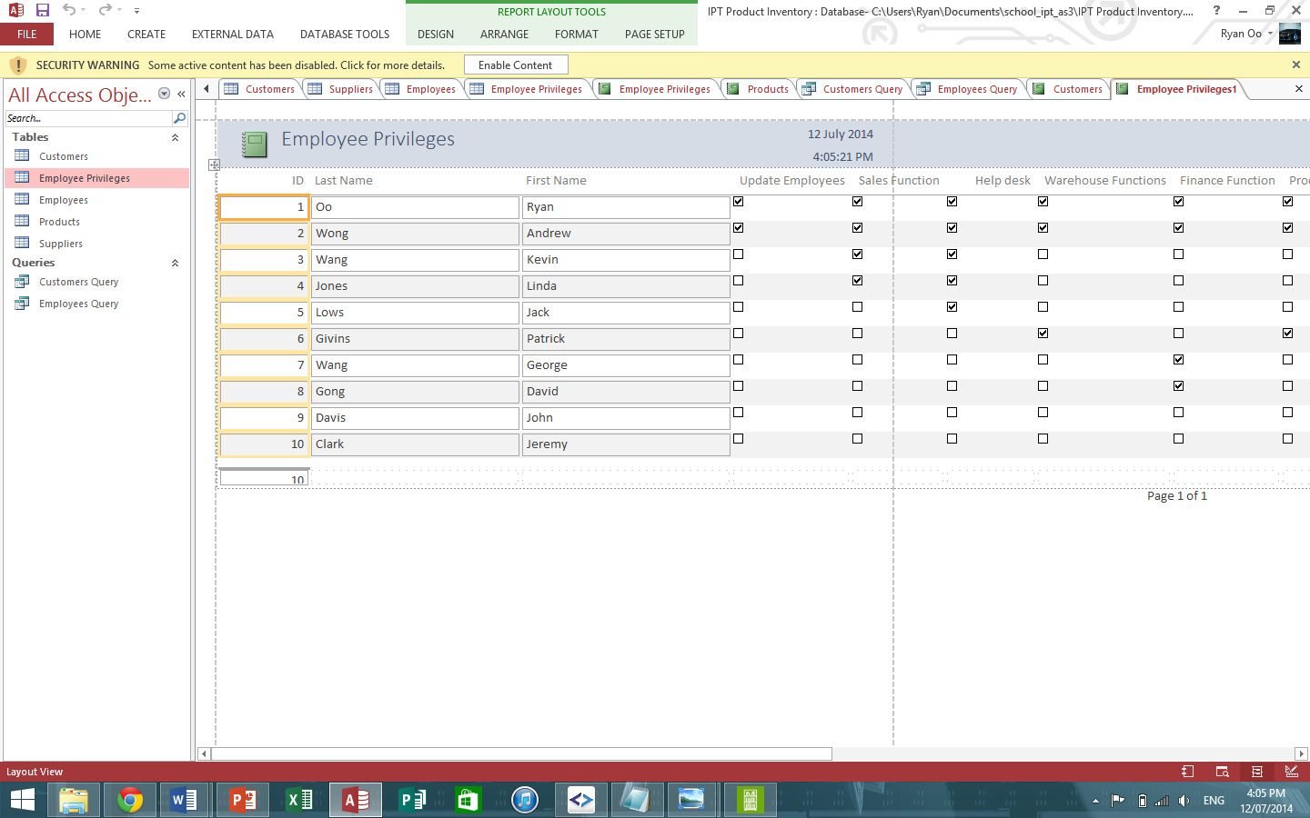

The following is an example of an Employee query using selected fields. An example of a report created using Access using, the Query Wizard. The fields included are: ID, Last Name, First Name, Address, Date Employed, Salary, Phone Number and Email Address. The search criteria includes a date employed date of greater than 1/1/2013 and a salary greater than $50000.

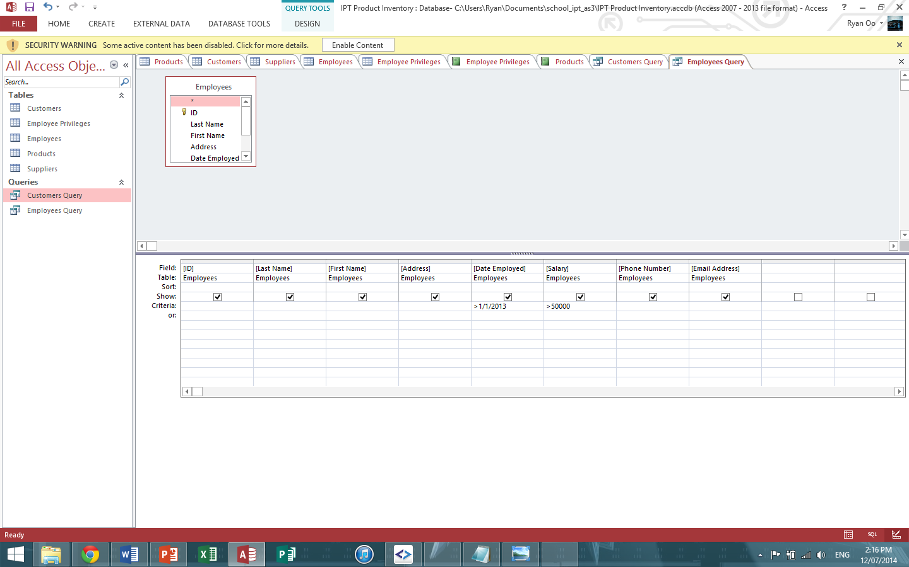

The result of this selective reporting is shown below for employees that started work after a date employed date of greater than 1/1/2013 and a salary greater than $50000. If we open the SQL View tab, this is the SQL command created by my Query.

*SELECT Employees.[ID], Employees.[Last Name], Employees.[First Name], Employees.[Address], Employees.[Date Employed], Employees.[Salary], Employees.[Phone Number], Employees.[Email Address]*

*FROM Employees*

*WHERE (((Employees.[Date Employed])>#1/1/2013#) AND ((Employees.[Salary])>50000));*

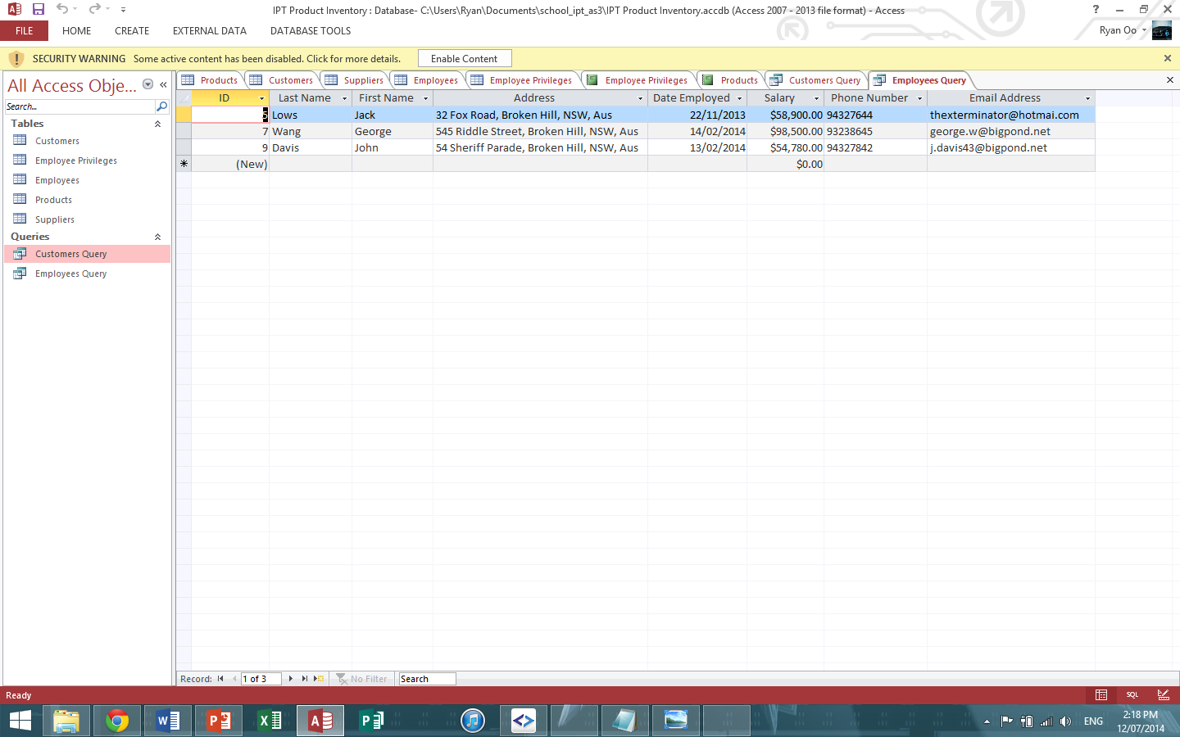

# Other Design Items

## Broken Hill Surf Shop – Advertisement

To all the surfers in Australia and the world! If you want the best quality surfing gear at the best price ever, login to Broken Hill Surf Shop website at [www.bhsurfing.com.au](http://www.bhsurfing.com.au) for the best deal. We guarantee our products for 5 years and will replace any surfing gear that you are not happy with. If you choose to be a loyalty customer, we will accumulate points on your every purchase which go towards a discount on your next purchase. If you happen to visit Broken Hill and our shop, you will get a further 10% discount just from coming into our shop. Our online store specials this week is our famous high quality Long Boards with a huge 10% discount! We look forward to seeing you in our store or online.

## Broken Hill Surf Shop – Customer Invoice

Our customer invoices also have our exciting company logo and shows customer information, delivery details and products and prices of products purchased.

